Charles Ramsey
Chairman
Michael Pennington
Executive Director

OVS Newsletter
June 1, 2022

In this Issue...
- PMR Update Communication
- VOCA Changes To Fiscal Year (FY) Reporting
- Attention VOJO Programs – VOJO Lapsing Funds – Please Don’t Forget To Use Your VOJO Funding By June 30, 2022!
- Guns Have Become The Leading Cause Of Death For American Kids
- News Coverage of Mass Shootings Has Become Ritualized
- Top Southern Baptists Plan To Release Secret List of Abusers
- COVID- 19, shootings: Is Mass Death Now Tolerated In America?
- Guidance For Supporting Groups And Teams After A Traumatic Event
- Age- Related Reactions To A Traumatic Event
- Updated Guidance On Improving Law Enforcement Response To Sexual Assault And Domestic Violence
- How Can HR Help After Racially Motivated Shooting?
- OVC Funding Opportunities

Upcoming Trainings & Events
- VCAP Quarterly Discussions
- Runaway And Homeless Youth Program Grant Opportunities Available
- Sex Trafficking Happens Here – A Statewide Campaign
- Group Crisis Intervention Training
- Monthly Monday Night Meet Up: Gun Violence Prevention Month
- Combatting Commercial Sexual Exploitation Through Law And Policy
- Digital Stalking & Other Technology Threats for Victims of Domestic Violence
- Creating Resiliency: Understanding Trauma For Crime Survivors Virtual Support Group
- July 2022 Foundational Academy
- Homicide & Drug Delivery Resulting In Death Cases And The Role Of The Victim Advocate
- Victims Compensation Assistance Program Online Trainings

Employment Opportunities
- Sexual Assault Resource Counseling Center (SARCC) - Employment Opportunities
- Schuylkill Hope Center – Employment Opportunities
- Safe Berks – Employment Opportunities
- Women’s Resources Of Monroe County – Employment Opportunities
- PCADV – Employment Opportunities

Return to top

PMR Update Communication

Recently, the E-grants system was updated to make it easier for grantees to submit Project Modification Requests (PMRs). One of the specific changes that impacts OVS-funded programs, is the addition of the Personnel PMR (Name Change Only).

With the addition of the Personnel (Name Change Only) PMR, OVS will no longer require the submission of the quarterly personnel spreadsheet beginning with the quarterly reports due in July 2022. Therefore, when there is a change in staffing of an approved position with less than a 10% budgetary change of the entire personnel budget category, the Personnel (Name Change Only) PMR must be filed. Subgrantees should file the modification at the time the change in staffing occurs and not in conjunction with quarterly reporting. A signature pages is not required for a Personnel PMR.

NOTE: If the personnel change has a budgetary change that is 10% or higher than the entire personnel budget, then a Full PMR will need to be completed.

If you have any questions concerning the new PMR process, please contact the OVS Program Staff assigned to your grant(s).

Return to top

VOCA Changes To Fiscal Year (FY) Reporting

Beginning on October 1, 2022, the VOCA reporting year will be shifted to align with the federal fiscal year (October 1st to September 30th). PCCD has been operating on the state fiscal year of July 1st – June 30th for VOCA reporting purposes. This change is occurring due to federal reporting requirements and will allow for the annual VOCA anecdotal information to be submitted at the end of the federal fiscal year.
This reporting change will take effect with the reporting period of 7/1/22 to 9/30/22 being a transition quarter and October 1, 2022 starting the beginning of a new fiscal year reporting period.
Transition to Federal Fiscal Year (Transition Quarter)
Beginning July 1, 2022, the reporting year will shift to the federal fiscal year of October 1st to September 30th reporting time frame. This “transition quarter” will allow for agencies to include July 1st – September 30th VOCA report data as the last reporting period for the year. Data will be counted as follows:
- July to September 2022 Reporting Period will count New and Continuing with the Fiscal Year Start Date of 10/1/21.
  - VOCA funding recipients are being asked to make this counting and tracking change beginning 7/1/22 and be able to report these numbers for the July 1st, 2022 – September 30th, 2022 VOCA reports that are due to PCCD via EGrants on 10/15/22
  - If a program is unable to accommodate this change for the July 1st, 2022 – September 30th, 2022 quarter due to data tracking system limitations and needs to report this quarter using the previous method of a fiscal year start date of 7/1/2022, no issue will be made with regards to NEW and CONTINUING victims served.
  - VOCA funding recipients are required to begin tracking all victims served as “New” for the October 1st, 2022 to December 31st, 2022 (1st quarter) reporting period to align with the use of the 2022/2023 Federal Fiscal Year of October 1st, 2022 to September 30th, 2023.
No Changes for Previously Submitted VOCA Reports
The quarterly reports up to and including the April 1st to June 30th, 2022 reporting period will not need to be resubmitted or changed to align with the new federal fiscal year reporting period.

Reporting Timeframes for 2022
The following table illustrates the reporting requirement timeframes for the remainder of the 2022 calendar year.
Reporting Period | Fiscal Year Start Date | New and Continuing | Quarter | VOCA Report Due Date
January to March 2022 | 7/1/21 | New and Continuing | Quarter 3 | April 15, 2022
April to June 2022 | 7/1/21 | New and Continuing | Quarter 4 | July 15, 2022
July to September 2022 | 10/1/21 | New and Continuing | Quarter 4 | October 15, 2022
October to December | 10/1/22 | Everyone New | Quarter 1 | January 15, 2023

ETO Case Management Users Impact
- No required changes needed by ETO Case Management Users.
- The VOCA Reports have their reporting year start date in the report prompt screen. The Fiscal Year Start Date will begin to default to 10/1/21 at the end of August.
- This change does not impact the PCADV and PCAR reports that are on a State Fiscal Year (SFY)
ETO Aggregate Users Impact
- VOCA recipients who use their own data tracking methods and case management systems must update their tracking and reporting methods to correspond with new reporting time frame.
- A grace period for the July – September reporting cycle will be given to those agencies that are unable to adjust their reporting method prior to July 1st.
If you have any questions, please contact Jennie Seigler at jseigler@pa.gov or at 717-265-8745.

Return to top

Attention VOJO Programs – VOJO Lapsing Funds – Please Don’t Forget To Use Your VOJO Funding By June 30, 2022!

Recipients of 2021 VOJO (VJ), denoted on your Award Letter as:

2021 VJ Award Amount $ XX.xx
2021 VJ Project Period 7/1/2021 - 6/30/2022

This is a reminder that VOJO funds not expended or obligated from this funding source by June 30, 2022 will lapse.

Any outstanding obligations as of 6/30/2022, should be reported in the Outstanding Subgrantee Obligations column on the fiscal report for the period ending 6/30/2022.
An interim fiscal report will need to be submitted once the reported Outstanding Subgrantee Obligations are paid. A remark must be included noting the reported expenditures were attributable to the period 7/1/2021-6/30/2022.

Return to top

Guns Have Become The Leading Cause Of Death For American Kids

Firearms were the leading cause of death for children one and older for the first time in 2020, Axios reports. The firearms death rate among children is steadily rising, as more kids are involved in gun-related homicides.

Please click here to read more.
Return to top

News Coverage of Mass Shootings Has Become Ritualized

Media coverage of the massacre in Uvalde feels like a grotesque deja vu —police alerts, a teeming crime scene, the live helicopter shots, the family tragedies and another round of inconclusive debates about gun control and mental health, says the Washington Post.

Please click here to read more.
Return to top

Top Southern Baptists Plan To Release Secret List of Abusers

Southern Baptist Leaders plan to release a secret list hundreds of pastors and church-affiliated staff members in response to an investigative report detailing mishandling allegations of sex abuse.

Please click here to read more.
Return to top

COVID- 19, shootings: Is Mass Death Now Tolerated In America?

Americans have always tolerated high rates of death among certain segments of society. But the sheer numbers of deaths from preventable causes, and the apparent acceptance that no policy change is on the horizon, raises the question: Has mass death become accepted in America?

Please click here to read more.
Return to top

Guidance For Supporting Groups And Teams After A Traumatic Event

The Office of Victim Assistance at the University of Colorado, Boulder published a guide and sample outline to help offer informal support and self-care sessions after traumatic events.

Please click here to access.
Return to top

Age- Related Reactions To A Traumatic Event

From the National Child Traumatic Stress Network (NCTSN) this resource guide describes how young children, school-age children, and adolescents react to traumatic events and offers suggestions on how parents and caregivers can help and support them.

Please click here to access.
Return to top

Updated Guidance On Improving Law Enforcement Response To Sexual Assault And Domestic Violence

The Department of Justice recently announced guidance to help law enforcement agencies recognize and prevent gender bias from compromising the response to, investigation of, sexual assault, domestic violence and other forms of gender-based violence.

Please click here to read more.
Return to top

How Can HR Help After Racially Motivated Shooting?

How can employers support the mental health of employees through challenging times

Please click here to read more.
Return to top

OVC Funding Opportunities

Please click here to see current funding opportunities.
Return to top

Powerful Partnerships: Collaberative Efforts To Address Human Trafficking Affecting AAPI Communities

Alia El-Sawi, a Victim Assistance Specialist at the Department of Homeland Security, joins API-GBV for our first “fireside chat” hosted by our Executive Director Monica Khant. Drawing also from her previous role as the Anti-Human Trafficking Coordinator at a community-based organization that provides culturally-responsive services for survivors of human trafficking, Alia will discuss what can be done to increase coordination and communication between DHS agents and community-based advocates in responding to trafficking situations and minimizing trauma for survivors. The conversation will also illuminate challenges to current anti-trafficking efforts, including fear of reporting, human-trafficking’s concurrence with other forms of gender-based violence, and the abundant stereotypes around the trafficking of AAPI individuals.

Please click here to view.
Return to top

VCAP Quarterly Discussions

VCAP will be holding quarterly discussions for those who file VCAP claims. Our next virtual meeting will be on Tuesday, June 21, 2022 at 10:00-11:30 am. If you are interested in attending this discussion, please complete the registration form by Friday, June 10, 2022. A link to the Microsoft Teams meeting will be sent the week of June 13, 2022 to those who have registered. If you have any topics you would like to discuss, please include them on the registration form. We will do our best to cover any suggested topics. Click here to register.

Return to top

Runaway And Homeless Youth Program Grant Opportunities Available

Funding: National Safe Place Network (NSPN) is pleased to share the release of the 2022 Runaway and Homeless Youth (RHY) Street Outreach Program (SOP) funding opportunity announcement (FOA). All applications must be received by 11:59 p.m. EDT on June 6, 2022. This funding opportunity is for a 36-month project period with three 12-month budget cycles. The SOP provides street-based services to runaway, homeless, and street youth who have been subjected to or are at risk of being subjected to sexual abuse, prostitution, sexual exploitation, and severe forms of human trafficking in persons. These services, targeted in areas where street youth congregate, are designed to assist such youth in making healthy choices and providing them access to shelter as well as basic needs, including food, hygiene packages and information on a range of available services. Learn more.

Return to top

Sex Trafficking Happens Here – A Statewide Campaign

On June 1, the PA Office of Victim Advocate – with partners Villanova Law Institute to Address Commercial Sexual Exploitation and Mission Kids Children’s Advocacy Center – will launch a statewide campaign to raise awareness of child sexual exploitation.

Please join us via the below social media sites and sharing messages that combat the myths of sex trafficking and dispel the misconception that trafficking “doesn’t happen here.”

Instagram: @traffickinghappenspa
Facebook: https://www.facebook.com/Trafficking-Happens-106596808719435
Twitter: https://twitter.com/traffickingpa

For additional information and resources, please contact Ashley Walkowiak at anwalkowiak@pa.gov.

Return to top

Group Crisis Intervention Training

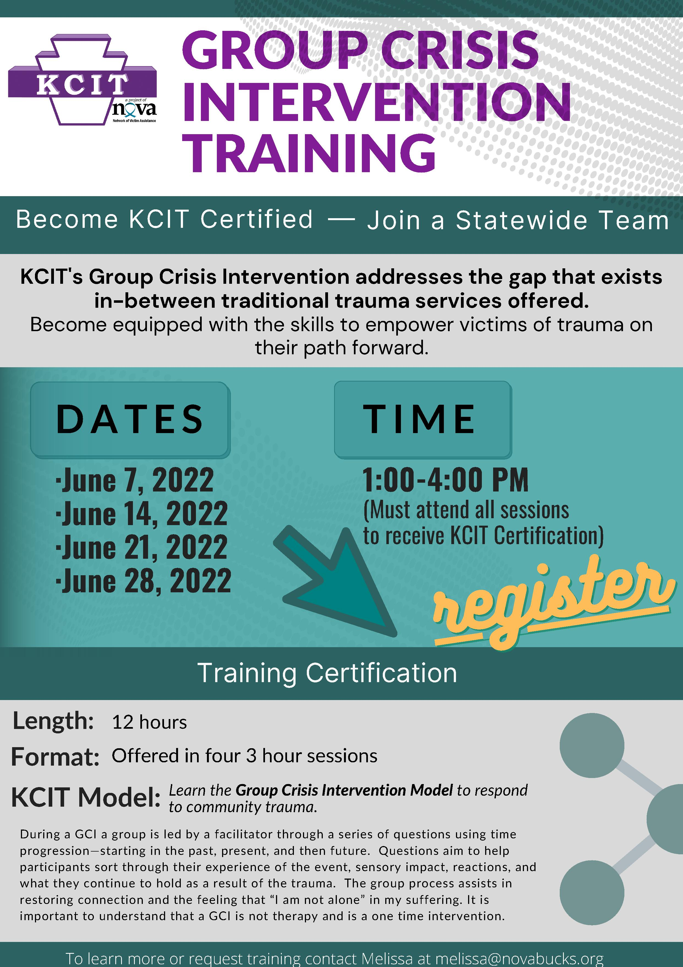

Return to top

Monthly Monday Night Meet Up: Gun Violence Prevention Month

Join the PA Office of Victim Advocate via Facebook Live for our monthly Monday night public forum on June 6 at 7:00 pm while we discuss the causes and responses to gun violence.

We will hear from regional experts at Unified Erie and Resolve Philadelphia, as well as national leader Crime Survivors for Safety and Justice.

Return to top

Combatting Commercial Sexual Exploitation Through Law And Policy

Tuesday June 7 8:00 AM – 5:00 PM
Attendees will receive an email from Eventbrite with the Zoom link prior to the event and can choose to join either in-person or virtually to receive CLE credit.

It is imperative that the experiences of survivors inform the development of policies and law reform to combat commercial sexual exploitation. Survivor voices must remain front and center of the anti-trafficking movement as we shape policy, provide services and work toward a world where commercial sexual exploitation is a relic of the past.

For this year’s symposium, please join us for cutting-edge panel presentations from survivors, lawyers and law reformers.

Please click here to register.
Return to top

Digital Stalking & Other Technology Threats for Victims of Domestic Violence

Women In Need Presents:
Digital Stalking & Other Technology Threats for Victims of Domestic Violence
Rob Shoop, Founder Lead Consultant
Supervisory Special Agent- Retired
Pennsylvania Office of Attorney General
Computer Forensics Unit
Technology saturates our everyday lives. Whether it is placing a phone call, owning a cell phone, taking a digital photo, logging onto a Social Network, or using any number of other common everyday technologies an individual is potentially revealing some detail of their personal life or their assignment. Technology has made our lives simpler but also makes it very easy for a stalker or other criminal to uncover and use this information to stalk, hurt, or harass you. This is a unique and eye-opening class for prosecutors, law enforcement, victim advocates, school personnel and anyone working in the judicial system who wants to learn more on how everyday technologies are being used (or misused) to avoid or detect investigations, stalk someone, or to learn personal details about a person and their families. Not only will this class examine and demonstrate how individuals are unwittingly providing information about themselves and their activities, it will also reveal the ways perpetrators are accessing the information. However, most importantly, the training provides investigative tools and simple, inexpensive ways to help mitigate that loss and protect the information.
WHEN: June 16, 2022
WHERE: Zoom
Time: 9:00 am to 3:00 pm
COST: FREE-STOP Funded
To register, please follow this link or return the completed registration form to Eric Williams, Direct Services Manager: ericw@winservices.org by Monday, June 13
*Robert Shoop is an investigator and computer forensics expert with extensive experience providing investigative and computer forensic support.*

This project was supported by grant No. 36019 awarded by Pennsylvania Commission on Crime and Delinquency. The opinions, findings, conclusions, and recommendations expressed in in this training are those of the speaker and do not necessarily reflect the views of this state or the Department of Justice, Office of Violence Against Women.

Return to top

Creating Resiliency: Understanding Trauma For Crime Survivors Virtual Support Group

The PA Office of Victim Advocate is offering a free, virtual support group for crime survivors. Creating Resiliency: Understanding Trauma for Crime Survivors is a 6 week program for any crime survivor in Pennsylvania.
Group 1 will meet Wednesdays 6:00 – 7:00 pm, beginning June 22.
Group 2 will meet Thursdays 12:00 – 1:00 pm, beginning June 23.
Interested survivors should complete the interest form and email it to Lisa Ryan at lmryan@pa.gov.

Return to top

July 2022 Foundational Academy

The next Academy in 2022 will be held as follows: July 13 - 15, 2022 at The Graduate Hotel 125 South Atherton Street State College, PA 16801 This is an in-person training only; there is no virtual or hybrid option.

There is no charge for Academy, and single hotel rooms, parking, and lunch are included. Participants are on their own in the evenings.

Registration will be open May 16 - 18, 2022 under the PDAI Training Calendar at www.pdaa.org. Trainings are listed by date; you will need to scroll down to July to find the information.

There is a NEW registration process for 2022: Registration will be open for the May 16-18th only. During this time, those who wish to attend the July Academy will be asked to apply for a spot. Information on funding and length of time at Agency must be completed as part of this process. Registrations will no longer be automatic and accepted on a first-come, first-served basis. Instead, applications to attend will be prioritized by, but not limited to, length of time at agency, number of spots filled by the agency in 2021/March 2022, etc.

Once prioritized, the top 60 applicants will be notified of their acceptance into Academy. All others will be placed on the waitlist and notified of such. The selection process will take up to 2 weeks. All pending applicants will be contacted as soon as the lists are finalized. We ask for your patience during that time period; as a reminder, we will contact you either way.

As a reminder, Academy spots are only for those VOCA, VOJO, and RASA-Funded individuals for whom attendance is required per PCCD’s Consolidated Victim Services Standards. Additionally, only a maximum of 8 staff members per agency may apply for each Academy.
Finally, applicants must be able to attend all 3 days of Academy in-person in its entirety, as well as complete an additional supplemental online training requirement.

If you have any questions or to request the supplemental online training form, please contact: Amy Smulktis, Restitution & V/W Training Consultant E: AJS@RestitutionConsulting.comT: 717.333.2319 B: PDAA/I 717.238.5416/www.pdaa.org

Return to top

Homicide & Drug Delivery Resulting In Death Cases And The Role Of The Victim Advocate

September 8, In-Person ONLY (no hybrid or virtual option)
Best Western Premier, Harrisburg

Registration will open June 8, 2022 to 50 participants
Registration Fee: $25 (payable by credit card or check)

Presenters: Stephen R. Zawisky, Esq.
Chief Deputy District Attorney - Dauphin County DA’s Office with
Tonya Lupinacci, Esq.
Assistant Professor of Criminology at Immaculata University
Consultant at Saint Joseph's University's Center for Addiction and Recovery Education
Former Assistant District Attorney - Montgomery County DA’s Office

Topics covered will include different types and gradings of Homicides, Sentences – why not all Homicide defendants get life sentences, Plea Agreements – why they happen and how negotiations/agreements are determined, Dos & Don’ts when communicating with the families, and DDRD – a general overview that is helpful to victim service providers.

Attendees will be responsible for their own lodging arrangements (group rate available) and expenses unless receiving a scholarship.

Scholarships are available to offset the expenses of attending! This includes overnight lodging, mileage, tolls, and a meal per diem. Contact Amy Smulktis at ajs@restitutionconsulting.com ASAP to apply; applications will be accepted prior to the opening of registration.
.
Return to top

Victims Compensation Assistance Program Online Trainings

The following trainings will be held on June 7, 2022.
- Myths of Compensation – 9:00 a.m. – 10:00 a.m.
- “Wow, That’s Covered by Compensation” – 10:30 a.m. – 11:30 a.m.

The following trainings will be held on June 22, 2022.
- Motor Vehicle-Related Crime Expenses Clinic - 10:00 a.m. – 11:00 a.m.
- Loss of Support Clinic – 11:30 a.m. – 12:30 p.m.

The following trainings will be held on July 7, 2022.
- Basic Compensation – 9:00am. – 11:00 a.m.

All trainings count towards 1 hour of the required RASA/VOCA/VOJO training hours, except Basic Compensation which counts towards 2 and DAVE training which counts towards 2.25.

Please click here to register.

Return to top

Sexual Assault Resource Counseling Center (SARCC) - Employment Opportunities

Please click here to see current employment opportunities.
Return to top

Schuylkill Hope Center – Employment Opportunities

Please click here to see current employment opportunities.
Return to top

Safe Berks – Employment Opportunities

Please click here to see current employment opportunities.
Return to top

Women’s Resources Of Monroe County – Employment Opportunities

Please click here to see current employment opportunities.
Return to top

PCADV – Employment Opportunities

Please click here to see current employment opportunities.
Return to top

The next OVS Newsletter will be published on Wednesday, June 8, 2022. If you would like any training events, fundraisers, or notable news published in this newsletter, please submit them to Lea Dorsey at ledorsey@pa.gov by Wednesday, June 15, 2022.

You have signed up to receive the OVS Newsletter from the Office of Victims' Services. This newsletter will be sent to you on a biweekly basis via email. If your email address changes or you would like to be removed from the OVS Newsletter distribution list, please contact Lea Dorsey at (717) 265-8733 or via email at ledorsey@pa.gov.
Return to top
Pennsylvania’s Office of Victims’ Services | 3101 North Front Street | Harrisburg, PA 17110 |
(717) 783-0551
www.pccd.pa.gov
PA Crime Victims Website
www.pcv.pccd.pa.gov
Twitter: @PaCrimeComm.

